6A^{th} Grade: Unit 9, Lesson 7

- Based on the line plot, how many students completed the survey?
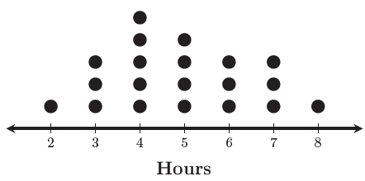
20

- When creating a line plot, what happens if a value appears in a data set more than once?

It needs to be plotted the amount of times it shows in the data set.

- Based on the line plot, what is the range of hours?
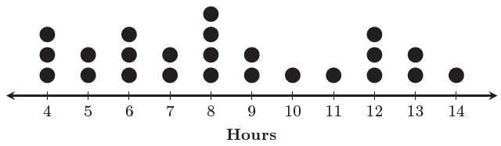
10

